English | Maths | Topic
Word search for kids - Puzzles  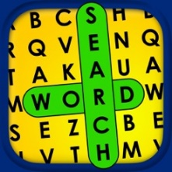 | Math Learner: Cool Maths Games  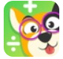 | Hopscotch-Programming for kids  
Spelling bee lists 1000+ spelling  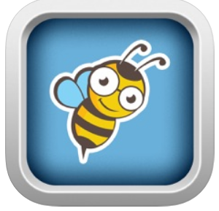 | Year 3: maths games for kids  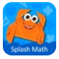 | codeSpark Academy: kids coding  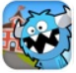
Spelling City  Improve vocabulary and spelling with this app.  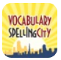 | Educational children’s clock - Improve time reading skills.  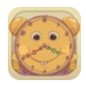 | Kids world atlas  Let your kids learn about the wonder of our world  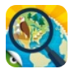
Teach your monster to read  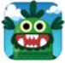 | SKIDOS  100’s of maths games for all levels  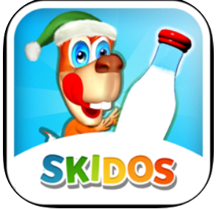 | Stack the countries  Build map reading skills with this interactive app.  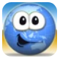
Spelling games for kids  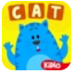 | Running Noah- an app that helps kids improve their multiplication skills  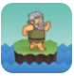 | Excavate! Egypt  Learn ancient Egyptian history in a brand new way with Excavate!  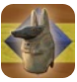
LetterSchool – Learn to write!  Handwriting app  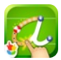 | Times tables rock Stars  All children have their own log in  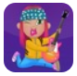 | Tynker: coding for kids  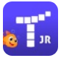
Sight words Learning games  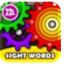 | Numbots  Addition & Subtraction. Solved. From the innovators who bring you Times Tables Rock Stars.  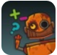 | Inventioneers  Invent your own game in 1 day!  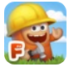
Epic! – Kids’ Books and videos  Leading digital library   | Grand Prix Multiplication  £0.49  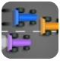 | Gliese: The science Adventure  Learn Science, coding basics and cyber safety  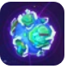
Endless Reader  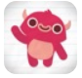 | Division Games for kids  £1.99  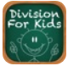 | Scratch Jr  Coding for beginners  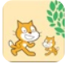
Read with phonics games  Read with Phonics is a colourful and interactive way for your child to learn their phonics sounds.  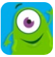 | Shape collector - £0.99  A game which teaches children to sort 2D and 3D shapes.  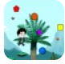 | Coding kids  Learn to make your own game in one day!  